Step 1: Advanced settings > Inbound rules > Protocol and Ports

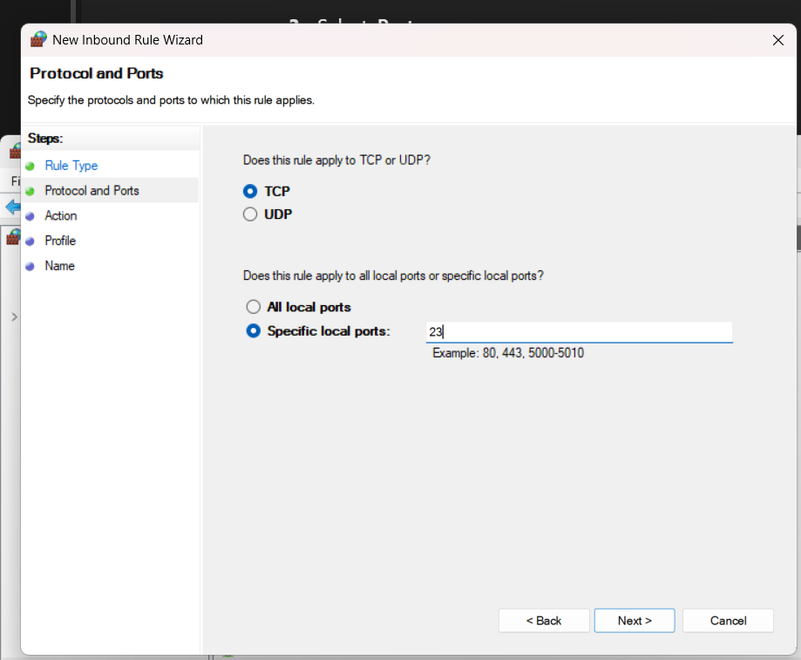

Step 2: apply rules to domain, private, and public

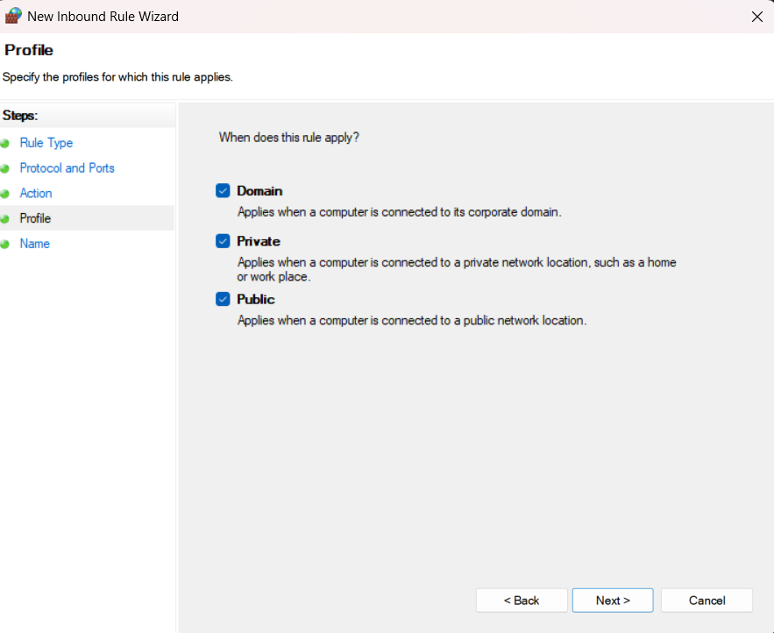

Step 3: give a name for new blocked rule, then click finish (add description optionally).

